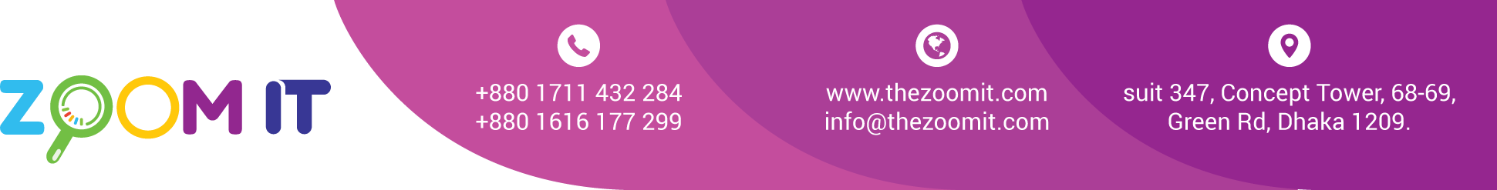

**Bill**

|  |  |
| --- | --- |
| Date | 08/08/2022 |
| INV. NO. | 10033 |

|  |  |
| --- | --- |
| Name | **ITS Holydays Ltd** |
| Address | House-150, Block-E, Road-10, Banani, Dhaka. |

|  |  |  |  |
| --- | --- | --- | --- |
| **Sl.**  **No.** | **Description** | **task** | **Value in Taka** |
| 1 | SEO  Server  Content Writing 5342 x1.5 = 8013  Last Month Due |  | 15,000  10,000  8,000  5,000 |
|  | | Total | 38,000 |
| Paid |  |
| Due |  |

BANK Details

Ac Name: ZOOM DIGITAL AC NO: 2228119002279

Prime bank Racecourse Branch

Signature